Apollo v4 control board - requirements

**Goal**

* Will serve as main controller board for a variety of small/medium PSA systems
* Reliability features: fault detection
* Diagnostics messages displayed on a TFT LCD

**PCB design requirements**

* Preferably at 10 cm x 8 cm
  + (but it could go higher if not possible such as 10 cm x 10 cm)
* 2 layer PCB preferably (with a ground plane)
  + (4 layer could be OK if ground plane hard to achieve)
* Eagle
* SMD preferred, pick&place will be done in a PCB manufacturer (Jlcpcb, pcbway, allpcb, etc)
* Multiple PCBs that can be stacked in a modular (Cubesat-like)fashion.
* The proposal is to have three boards:
  + Control board
    - Containing the ESP32, the TFT screen connector, battery circuit, buzzer, reset button
  + Valve board
    - Containing the valve drivers and the valve terminals
  + Sensor board
    - Containing JST connectors for the sensors

The project should reuse as much as possible the Apollo v3 control board document. Please see these links:

* Documentation: [link](https://docs.google.com/document/d/1zeXxTnBCQq67ddYeBdUPdo_KXUIRMmLPwQMJQMkbk8E/edit)
* PCB design:
  + controller board: [link](https://github.com/oxycon/ProjectApollo/tree/master/electrical/apollo-ctrl)
  + MUX sensor board: [link](https://github.com/oxycon/ProjectApollo/tree/master/electrical/apollo-mpr-8x-mux)

**Power**

* Power input: 12 .. 24V (external)
* Internal down-converter to 12 V (if 24 V supplied)
* regulator to 5V and 3.3V
* Battery for buzzer activation if power goes down

**Valves**

* 12V or 24V
* 2-way and 5-way valves
* 1A max

**Solenoid control**

* 4x solenoids controlled
* Open/short load detection
* Fault detection (overcurrent)
* Max 1A per solenoid (typically 500..700 mA)
* Suggested controller: [DRV8806](https://www.ti.com/lit/ds/symlink/drv8806.pdf?ts=1594425304961&ref_url=https%253A%252F%252Fwww.ti.com%252Fproduct%252FDRV8806)
* Wiring: serial

**Main controller**

* ESP32 WROOM board
* <https://www.amazon.com/HiLetgo-ESP-WROOM-32-Development-Microcontroller-Integrated/dp/B0718T232Z>

**Display touchscreen**

* ILI9341 or similar (2.8” minimum, 3.2” preferable)
* Power requirements: 3.3V or 5V
* Signal: 5V or 3.3V

**O2 sensor (flow/concentration)**

* Sensor: Cubic Gasboard 7500E (datasheet [here](https://github.com/oxycon/ProjectApollo/blob/master/Prototype%20oxygen%20concentrator/docs/datasheets/Gasboard%207500E%20technical%20specification_2020.pdf))
* Power: 12V
* Connectivity: 5V TTL UART (TX/RX/GND)

**Pressure sensors**

* Two sensors (one at input, one at output)
* Type: TE or Honeywell (likely TE)
  + TE sensor is I2C - datasheet [here](https://www.te.com/commerce/DocumentDelivery/DDEController?Action=srchrtrv&DocNm=MS5837-30BA&DocType=DS&DocLang=Englis)
    - Goes up to 30 bar (appropriate for input from compressor)
    - (Need to complete evaluation)
  + Honeywell sensor is SPI or I2C - datasheet [here](https://www.arrow.com/en/products/mprls0030pg0000sa/honeywell)
    - SPI is for high gauge pressure (30 psi max)
    - I2C is only for near-atmospheric pressures
* Apollo Mount board
* Two variants (final one TBD)
* 3.3V signal/power

**Buzzer**

* Main choice: TBD, but likely Mallory medical compliant
  + <https://www.digikey.com/en/ptm/m/mallory-sonalert-products-inc/iec60601-1-8-compliant-medical-alarms>
  + IEC60601-1-8 Compliant Medical Alarms
* Alternative: SD1614T5-B5ME
  + Medical rating? (requires contacting Tektronix)
  + 85 dB @ 5V
  + <https://media.digikey.com/pdf/Data%20Sheets/TDK%20PDFs/SD1614T5-B5ME_Overview.pdf>
  + <https://www.digikey.com/product-detail/en/tdk-corporation/SD1614T5-B5ME/445-175287-ND/8017772>
* Alternative: AI-3035-TWT-3V-R
  + 100dB @ 3V, 10cm
  + <https://www.digikey.com/product-detail/en/pui-audio-inc/AI-3035-TWT-3V-R/668-1204-ND/1745457>

**Fuse**

* Fuse holder [link](https://www.digikey.com/product-detail/en/keystone-electronics/3568/36-3568-ND/2137306)

**Buttons/switches**

* On/off button (external)
* Buzzer silence push button
* Silencer push button ideally accessible sitting on top (on board) next to the TFT screen
* Board Reset button (already part of the ESP32 board)

**Terminals**

* Connectors for ILI9341 who sits on top
* Screwed terminal block for power and solenoid interfacing
* ESP32 board is pluggable
* O2 sensor (terminals TBD – possibly JST-XH or JST-RE?)
* 2x pressure sensors (terminals TBD – possibly JST-XH or JST-RE?)
* 0.1 header for Apollo mux board interfacing (layout same as Apollo Mux board v3)

**Appendix 1 – DRV8806**

- Datasheet: <https://www.ti.com/lit/ds/symlink/drv8806.pdf?ts=1594425304961&ref_url=https%253A%252F%252Fwww.ti.com%252Fproduct%252FDRV8806>

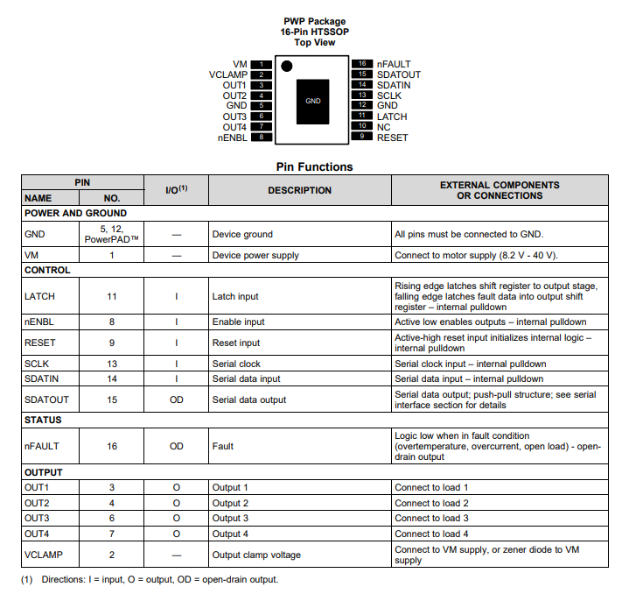

**Appendix 2 – ILI9341 2.8” TFT display**

<https://github.com/loboris/ESP32_TFT_library>